- Use Case diagram for WITHDRAW_MONEY of the Student Registration System
WITHDRAW_MONEY Use Case Description: Main Flow
User Action | System Response
1. User inserts ATM card | 1. System reads the card, checks its validity
2. User inserts ATM card and types in PIN into main screen | 2. System checks validity of PIN and presents options to user on another screen
3. User selects "Withdraw Money" from the options | 3. System displays a screen with available withdrawal amount options
4. User selects or enters the desired withdrawal amount | 4. System verifies that the amount is valid and sufficient, then dispenses the requested cash.
5. User confirm transaction | 5. System processes the transaction and displays a confirmation message
6. User chooses to print a receipt | 6. System checks the selection and prints the receipt (if selected)
7. User takes the ATM card | 7. System ejects the card and completes the transaction

- Create a Use Case Diagram for the ATM system

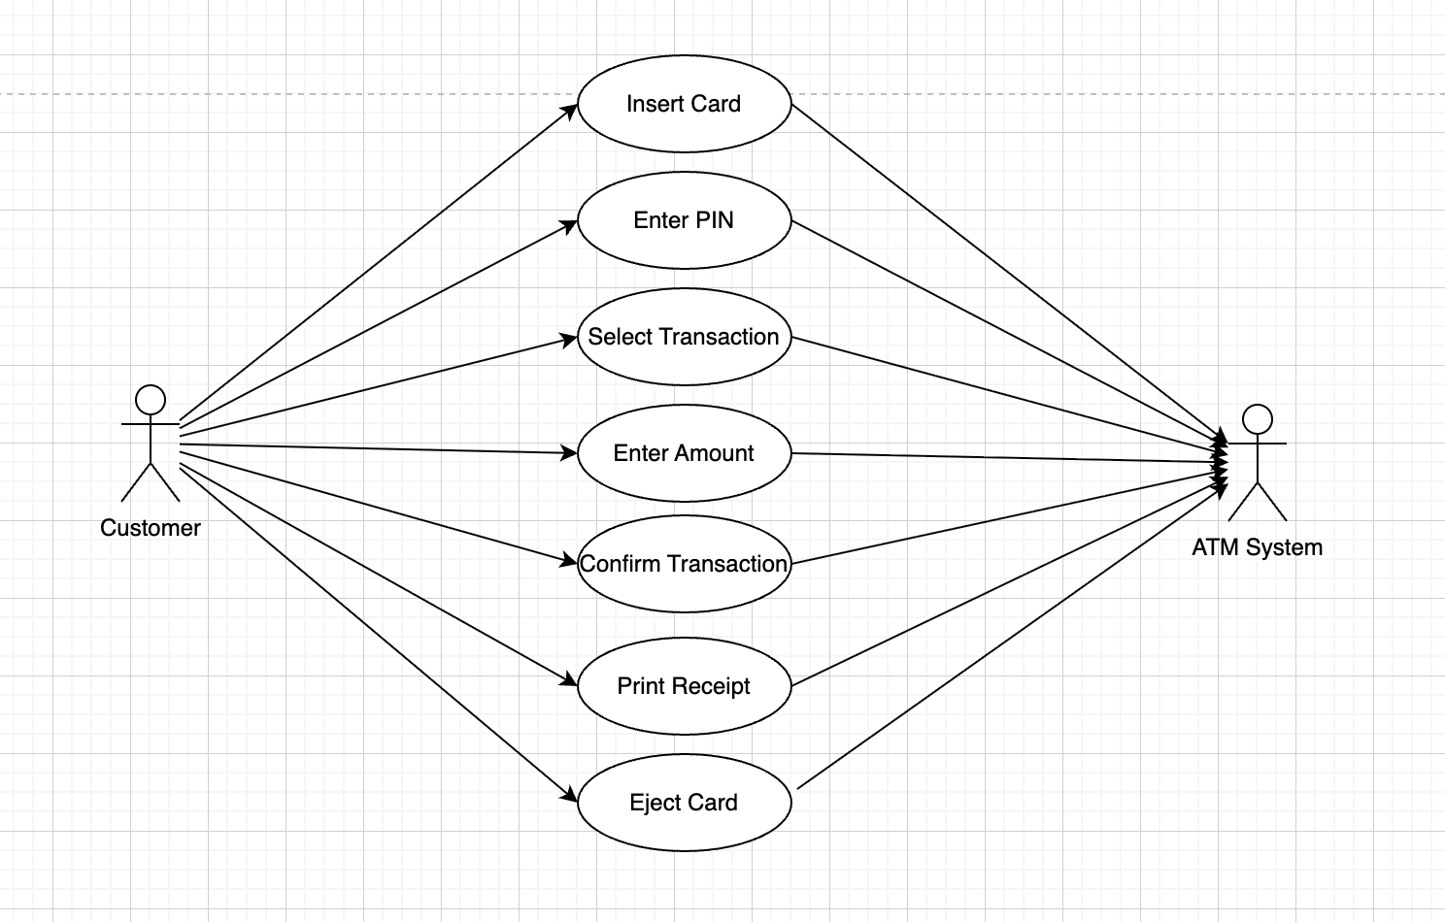

- Class diagram to model for The Project Management Tracking System
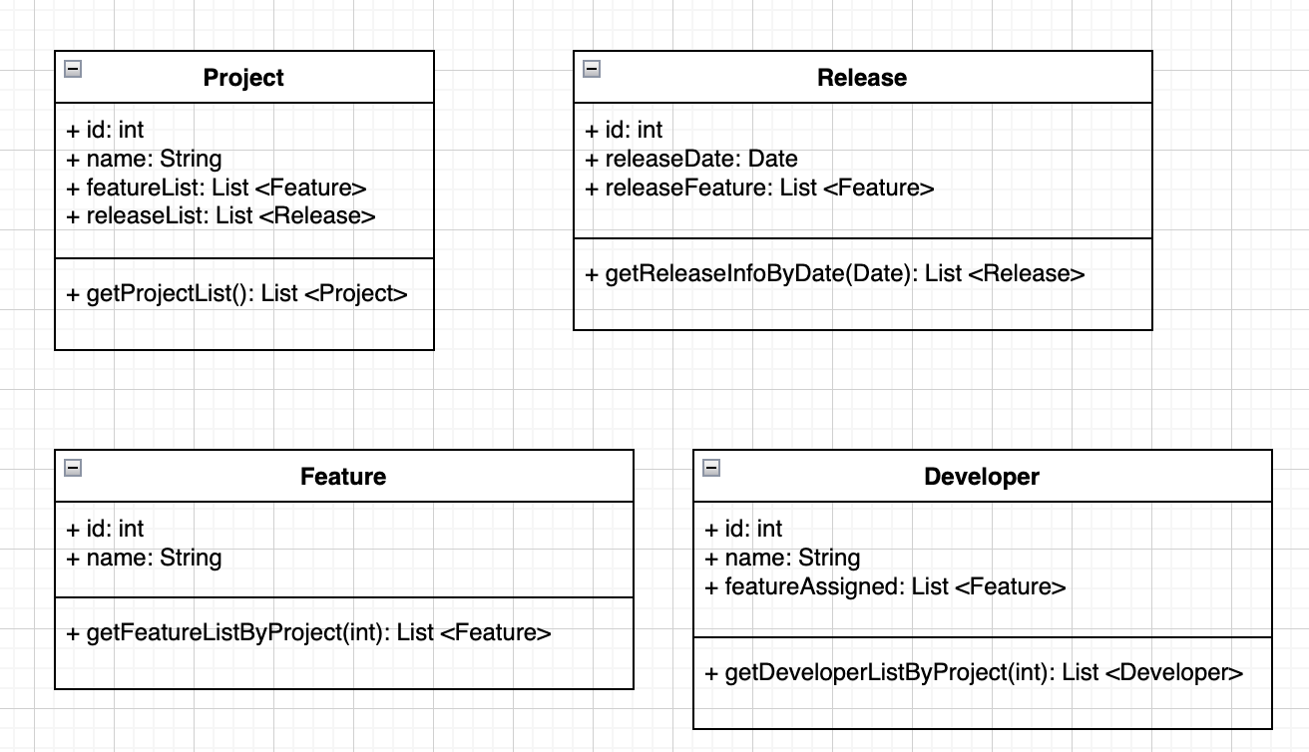

- Class diagram to model Properties Management System
